
SYMBIOSIS INSTITUTE OF TECHNOLOGY, PUNE
Symbiosis International (Deemed University)
(Established under section 3 of the UGC Act, 1956)
Re-accredited by NAAC with ‘A’ grade (3.58/4) | Awarded Category – I by UGC
Founder: Prof. Dr. S. B. Mujumdar, M. Sc., Ph. D. (Awarded Padma Bhushan and Padma Shri by President of India)

Assignment No. 08

Subject: | DevOps Lab
TCODE: | TE7950
Name of Student | Yash Patel
PRN No. | 23070122235
Branch | CSE, Batch (2023-27), L4
Academic Year &  Semester | 25 – 26, Sem VII
Date of Performance | 23rd July, 2026
Title of Assignment: | Dockerfile & Image Build
Theory: | Docker is a containerization platform that enables applications and their dependencies to be packaged into lightweight, portable containers. A Dockerfile contains the instructions required to build a Docker image, while a Docker image serves as a template for creating containers. A Docker container is a running instance of an image that provides an isolated environment for executing applications consistently across different systems. In this experiment, a simple Flask web application was containerized by creating the required application files, building a Docker image, running the container, and verifying the application through a web browser.  Commands Used  - mkdir my-flask-app – Created a new directory for the Flask application.  - cd my-flask-app – Navigated to the project directory.  - docker build -t my-flask-app . – Built a Docker image named my-flask-app from the Dockerfile.  - docker build --no-cache -t my-flask-app . – Rebuilt the Docker image without using cached layers after updating the dependencies.  - docker run -p 5000:5000 my-flask-app – Started the Docker container and mapped port 5000 of the container to port 5000 on the host machine for browser access.
Implementation: | Step 1: Create the Flask Application  Created Flask Application — Created the my-flask-app project directory and added the required application files. Implemented the app.py file containing a simple Flask web application that displays the message "Hello, Docker!" when accessed.  Step 2: Create the Requirements File  Created Requirements File — Created the requirements.txt file specifying the Flask dependency required to install the necessary packages for the Flask application.  Step 3 – Create the Dockerfile  Created Dockerfile — Created the Dockerfile specifying the Python base image, working directory, application dependencies, exposed port, and startup command required to containerize the Flask application.  Step 4 – Build the Docker Image  Built Docker Image — Successfully built the Docker image named my-flask-app using the Dockerfile. Docker completed all build stages and created the container image successfully.  Step 5 – Run the Docker Container  Executed Docker Container — Successfully started the Docker container and launched the Flask application. The application is running on port 5000 and is accessible through the host machine.  Step 6: Verify the Flask Application  Verified Dockerized Flask Application — Opened the Flask application in a web browser using http://localhost:5000 and successfully verified that the Docker container served the "Hello, Docker!" webpage.  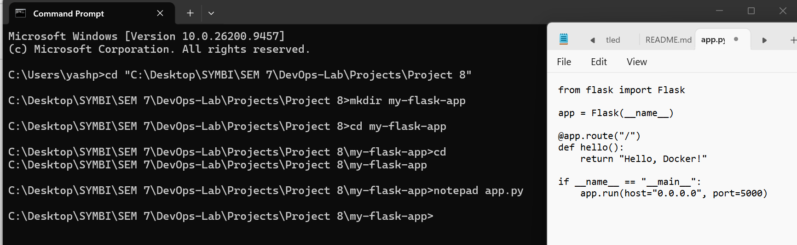  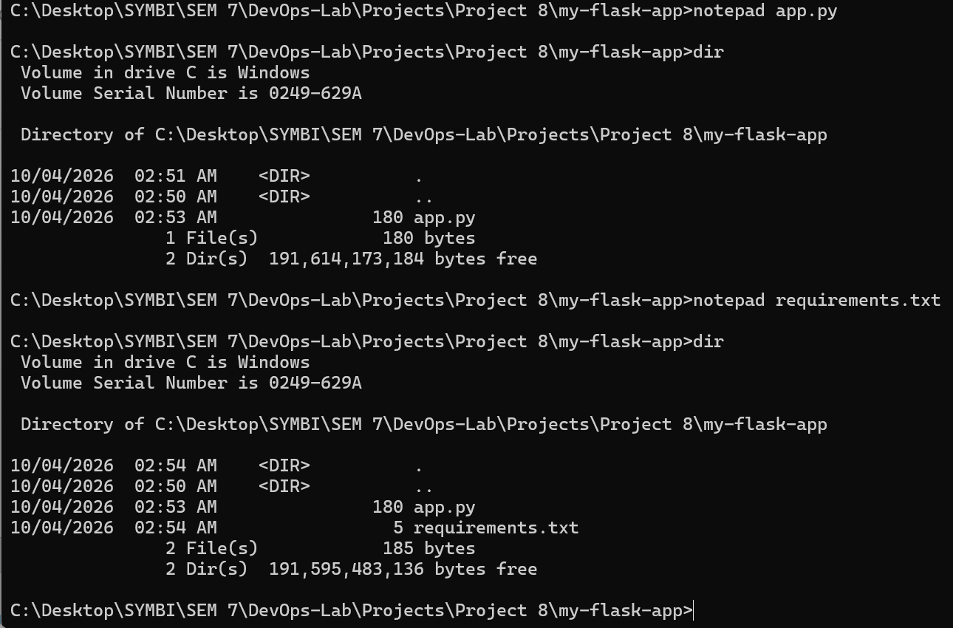  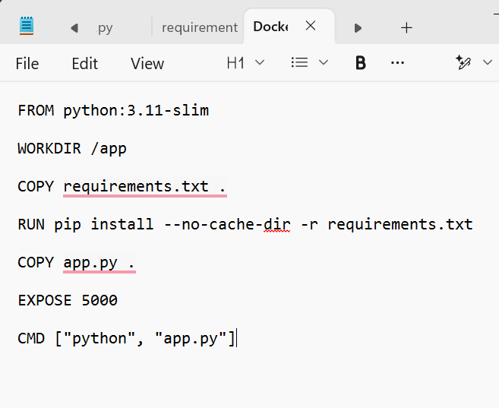  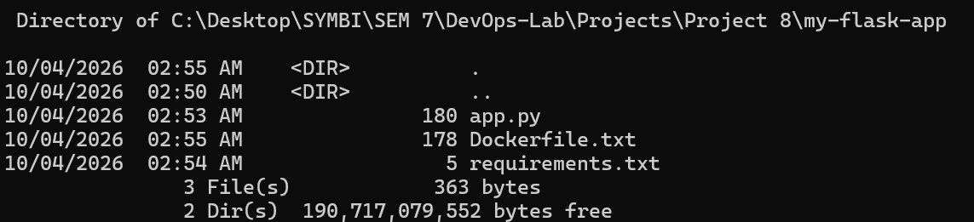  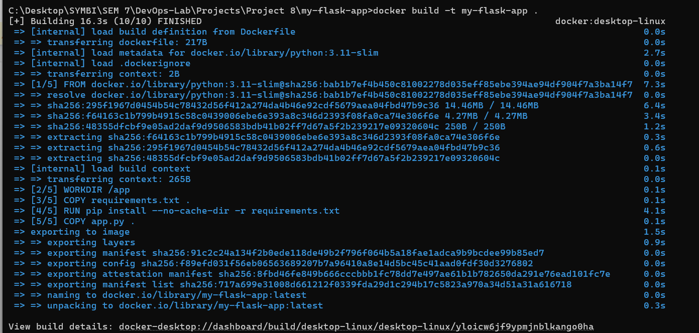  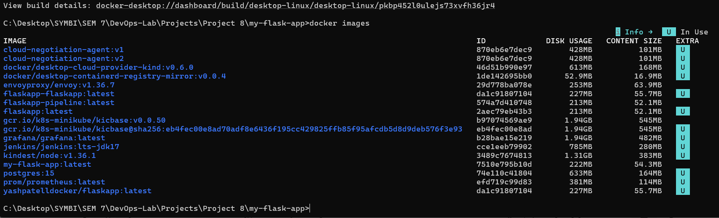  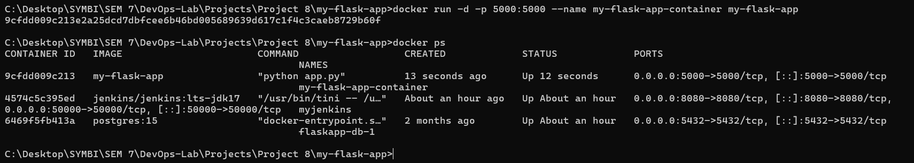  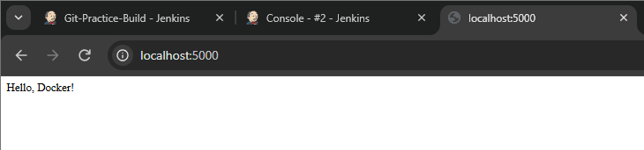

Subject Faculty Name: Prof. Arijit Dutta

